CPH Capstone Overview

Author: Josh Trimm

Edited by Joshua Trimm

Last Updated 29 August 2021

Contents

1 Summary 1

2 Definitions 1

2.1 Users 1

2.2 System 2

2.3 Development 2

3 Subsystems 2

3.1 Permissions 2

3.2 Authentication 2

3.3 Chart Management 2

3.4 Region Management 2

3.5 CSV Management 2

4 Out of Scope 2

5 Front-end Development 3

5.1 Design 3

5.2 Sitemap 3

5.3 Dashboard 4

# Summary

Dr. Wykoff and Dara have requested that we develop a web-based system that displays percentile charts, generated from data points associated with groups of U.S. counties. This data is to be downloaded from a web repository maintained by Community Health Resources ([www.chrhealth.org](http://www.chrhealth.org)) and stored in a database, by year, county, and health indicator. The groups of counties for which the charts shall be generated are to be specified by the clients and stored in the system’s database.

This system will need a web interface (how people will interact with the system), permissions module, a CSV uploading module for inputting the CHR data, a chart module, a region creation module, and deployment strategy. This should lay the groundwork, if built modularly, for further development by subsequent capstone participants.

# Definitions

## Users

* **Admin**: an individual with full permissions control. This user can add/remove cartographers, add/edit/remove regions, add/edit/remove charts, and add/remove uploaded CSV files.
* **Cartographers**: users who have been registered by the Admin user. Each cartographer can create charts and regions and edit and remove those charts and regions that (s)he has created. Cartographers can also upload the new CSV files as they become available: typically, once per year.
* **Browser**: users who navigate to the website in order to browse the charts created by the Admin or the Cartographers.
* **Chart Creators:** Admins and Cartographers
* **Region Creators**: Admins and Cartographers

## System

* **Region**(s): is a user-defined collection of two or more US counties.
* **Health Indicators:** are data points found in the CSV’s downloaded from the Community Health Resources website. These are the columns located at the top of the CSV[1].

## Development

* **AWS**: Amazon Web Services
* **D3**: a non-proprietary, standards-based JavaScript library for manipulating documents based on data. D3 supports the use of HTML, SVG, and CSS to create web pages and charts. D3 combines powerful visualization components with a data-driven approach to DOM manipulation (*d3js.org*).
* **Twitter Bootstrap**: A library for making websites fluid or responsive.
* **ASP.Net**: Microsoft’s C# library for web app development.
* **Subsystems**: loosely defined as features.
* **Features**: consists of one or more logically related system capabilities that provide value to a user and are described by a set of functional requirements (Wiegers & Beatty, 2013).

# Subsystems

This system has been architected as a set of five interacting subsystems, including two based on ASP.NET core and three custom subsystems. Each subsystem manages one aspect of the system’s opeation.

## Permissions

ASP.NET core’s permissions APIs allow developers to define roles and set permissions. Based on who is logged in – or not – the website will show different functionality.

## Authentication

ASP.NET core’s authentication APIs support the use of browser-file-based cookies to track users. It allows developers to specify when these cookies expire and removes cookies automatically when users log out.

## Chart Management

The Chart Management subsystem supports the creation, display, and editing of percentile charts. The second version of the Chart Management system should extend to other types of charts.

## Region Management

The Region Management subsystem allows the Admin and Cartographers to define custom regions. Regions will be saved with the date they are created and who created them. Each user who creates a region shall be able to modify that region’s makeup by adding counties to or removing counties from that region. This action of redefining a region, however, shall not affect any charts that have been created and stored for earlier versions of that region.

## CSV Management

Backend users of the CPH system will need to upload future and current year data points from the Community Health Resources ([www.chrhealth.org](http://www.chrhealth.org))***.*** This system uploads the CSV to a local directory (not industry best practice) and saves the file and names it with its associated year. In addition, who and when the document was uploaded will be recorded in the database.

# Out of Scope

* **Deletion of Cartographer** – Deleting a cartographer can cause chart failures. Extra functionality will be needed to ensure that chart ownership is transferred to another user. Client input will be needed as to how this transfer should be effected.
* **Removal of a Region** – Deleting a region could cause multiple chart failures. For future development, the client needs to be consulted as to how to handle this situation.
* **Disability accessibility** – Further work will be needed to assure the site’s eventual ADA compliance.
* **Deployment** – While instructions for deploying the system will be provided as part of this work, the actual work of deployment will be left to ETSU staff and faculty.
* **Logging** – Support for logging should be added to the system at some point, in order to track its use, including potential anomalies in its operation. ASP.NET core logging APIs could (and should) be used to support logging.
* **Additional charts** – Currently, the percentile chart is the only chart in development. The chart module will be developed in a way that will enable the ready addition of other types of charts and chart-related features.
* **CSV’s other than the health website** – currently the system is only designed to handle CSVs from the CHR. Other CSV’s will break the system and should not be used.
* **Beautification of UI** – Having a beautiful website that is UX optimized constitutes a project within itself. For the scope of this capstone, a usable responsive UI will be developed.
* **Saving CSV to an external file system (industry best practice)** – For now, all uploaded CSV’s will be stored locally. This is not industry best practice and should be addressed in a future iteration. Files being uploaded to the host’s directory could have malicious scripts and crash the system.
* **Advanced Filtering –** Additional search features for Regions, Health Indicators, Creator, or Year will need to be added in future iteration of the capstone. For this iteration, users will have one basic search functionality for each feature. *These are defined in the* ***Front-end Development*** *section.*
* **Map –** Currently the CPH had no interest in having a map displayed for users to select counties. This might be something they would consider in the future.
* **Two Factor Authentication (F2A) –** Microsoft offers an authitication service allowing users to setup F2A. Ideally, the F2A will be integrated into ETSU’s Microsoft Identity Platform to ensure that all users are members of ETSU.

# Front-end Development

The system’s web-based front-end will support all standard interactions with the system. Its navigation systems will provide access to its contents and features. Different navigation systems will be provided for different types of browsing.

## Search and Filtering

### Chart Creation & Editing

The chart creation & editing page will have fields to choose health indicators, CSV year, counties, and regions.

## Design

The website’s initial design will be quite basic, due to a lack of developer resources and a need to focus on implementing essential functionality. Basic usability features to view the website on all devices will be implemented using Twitter’s CSS-based Bootstrap library. Custom color schemes, layouts, and flashy displays are currently out of scope, as is support for users with impaired sight and other disabilities.

## Sitemap

* Back-end view (Dashboard) – only for the Admin and Cartographers
  + Home
    - Displays a user’s name and navigational icons for creating a region, creating a chart, browsing the charts that they have created, and browsing the regions they have created.
  + Create Region
    - Allows the Admin and Cartographer to create regions from a database-provided list of U.S. counties.
  + Create Chart
    - Allows the Admin and Cartographers to create a percentile chart to compare a region or county against the US, relative to a single type of data
  + Account
    - Displays the user's name and contact information and enables the editing of this information.
  + Edit Region
    - Allows Cartographers to edit a region they have defined. Allows the Admin to edit/remove any region.
  + Edit Chart
    - Allows Cartographers to edit a chart they have defined. Allows the Admin to edit/remove any chart.
  + CSV Upload
    - Allows the Admin and Cartographers to upload the yearly CSV data points from the CHR website.
  + CSV Browser
    - Displays the name of each uploaded CSV file, its upload date, and who uploaded that file.
* Front-end view
  + Home
    - Provides an overall description of the site and its functions
  + About
    - Provides a more in-depth description of the site does and the CPH
  + Contact
    - Displays the CPH’s contact information
  + Chart Browser
    - Displays all publicly available charts with a brief description of each chart.
  + Chart View
    - Displays a single chart's total information: i.e., the region name, the counties it contains, the chart’s datapoint, the creator’s username, the date of creation, the title, and the creator’s contact info.

## Dashboard

The dashboard is where the Admin and Cartographers will manage charts, regions, personal contact information, and CSV’s. It will consist of eight pages, as described in the Sitemap Back-end sections. Users with Admin and Cartographer permissions will be required log in to the system to view the dashboard. No other users will have access to the dashboard.

# Non-Functional Requirement

## External

|  |  |  |  |  |  |  |  |
| --- | --- | --- | --- | --- | --- | --- | --- |
| Attribute | Score | Availability | Installability | Integrity | Performance | Security | Usability |
| Availability | 2 |  | ^ | ^ | < | < | ^ |
| Installability | 3 |  |  | ^ | < | < | ^ |
| Integrity | 5 |  |  |  | < | < | < |
| Performance | 1 |  |  |  |  | < | ^ |
| Security | 0 |  |  |  |  |  | ^ |
| Usability | 4 |  |  |  |  |  |  |

## Internal

|  |  |  |  |  |  |  |  |
| --- | --- | --- | --- | --- | --- | --- | --- |
| Attribute | Score | Efficiency | Modifiability | Porability | Reusability | Scalability | Verifiability |
| Efficiency | 0 |  | ^ | ^ | ^ | ^ | ^ |
| Modifiability | 5 |  |  | < | < | < | < |
| Porability | 1 |  |  |  | ^ | ^ | ^ |
| Reusability | 4 |  |  |  |  | < | < |
| Scalability | 2 |  |  |  |  |  | ^ |
| Verifiability | 3 |  |  |  |  |  |  |

# Feature Tree

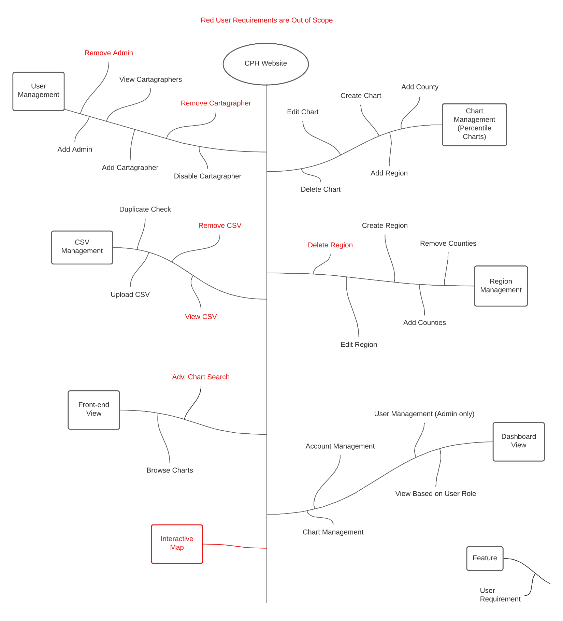

## Features

The features listed in the tree above are elabrorated on in separate functional requirements files.

* Interactive Map
* Dashboard View
* Front-end View
* Region Management
* Chart Management
* CSV Management
* User Management

1. These files can be found at this address: <https://www.countyhealthrankings.org/explore-health-rankings/rankings-data-documentation>